Introduction of the emergence evaluation framework

# 1. Environment required

Operating system:

Microsoft Windows 10

Software:

Python software, v3.6, <https://www.python.org/downloads/>. When you install python, do remember to add the python to PATH. Note: Matlab engine API for Python cannot support the python version later than v3.6. If your Matlab is x64 version, do remember to install the python with 64-bit. *Update at 5/22/2020:* Matlab engine API do support python v3.7 when I test in Matlab R2020a. Please install v3.7 if you can since the latest pytorch package (we used it in this framework) did not support python v3.6 anymore.

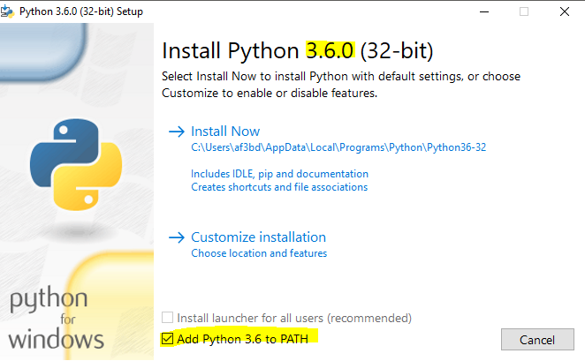

MathWorks Matlab software, v2018a or later, <https://www.mathworks.com/downloads/>

Packages and API:

Matlab engine API for Python, <https://www.mathworks.com/help/matlab/matlab_external/get-started-with-matlab-engine-for-python.html>

Go to <https://pip.pypa.io/en/stable/installing/> to download the pip and install it in cmd.

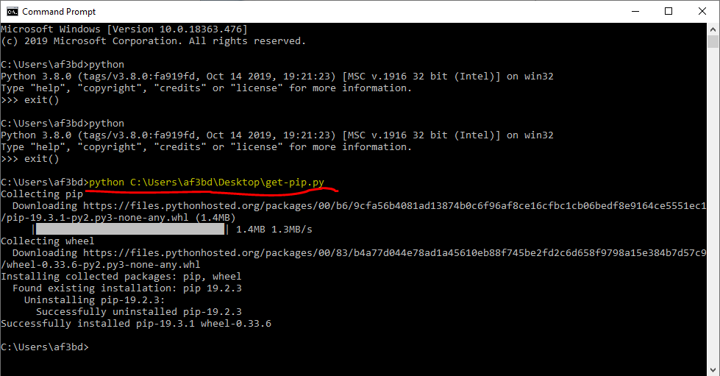

The following python packages could be installed by ‘pip install [Package name]’ command: opencv-python package, scikit-learn package, numpy package, pandas package, pytorch package, scipy package, matplotlib package and pillow package.

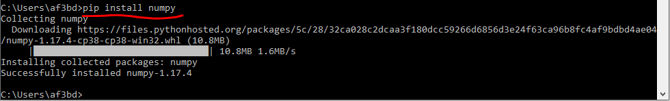

# 2. Download the framework

The framework can be download at <https://missouri.box.com/s/apzi9srxt3a9wltxdzr3534q0o2l3fdj>

The framework includes the following files:

|  |  |
| --- | --- |
| File | Description |
| gui.py | An easy use graphical user interface (GUI), users can start the framework here. |
| GetLabelimage.m | Read the raw RGB image frames, rotate the raw images, guide the users to select the regions had ground labels, segment each seedlings cluster, record the locations and id of the seedlings cluster, calculated row spacing, generate a file that asked the users to type labels on it. |
| LablesForMeter.m | Read the rotated images, row spacing file and visual labelling file, crop the images by meters from the raw image frame, calculate the seedling number and canopy size of each meter length image. |
| row_4 folder | Example images collected for the related paper. |
| meter folder | A folder generated by the framework that included the cropped images by meters from the raw image frames. |
| excel_data.csv | A file generated by the framework that included the id and locations of each segmented seedlings. Users will be asked to count the seedlings and type the labels in this file. |
| row_space.csv | A file generated by the framework that included the row spacing and the image coordinates of four corners of the rectangles the users drawn. |
| CNN_4_pretrained_regression.py | Build the resnet18 model and use the generated image data to train the parameters. |
| resnet18.pth | The trained model used the data set related to the paper. |
| extractMeterInImages.m | Segment the test images by meters and assign them GPS coordinates. |
| gps.csv | A file generated by the framework that included the image name of the segmented images and their related GPS. |
| CNN5_predict.py | Predict the stand count and canopy size. |
| seedling.csv | A file generated by the framework that included the prediction results of stand count and canopy size with their related GPS. |
| test_data folder | Example images provided for testing. |

# 3. The usage of the framework

Run the gui.py in cmd.

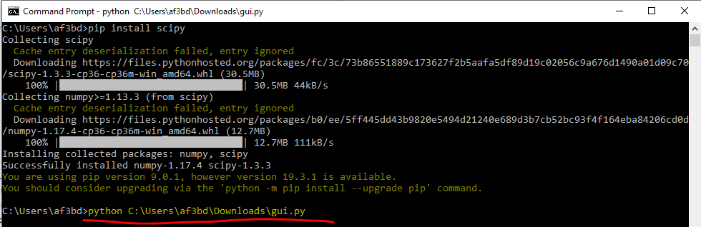

Then you will see the main window of the framework.

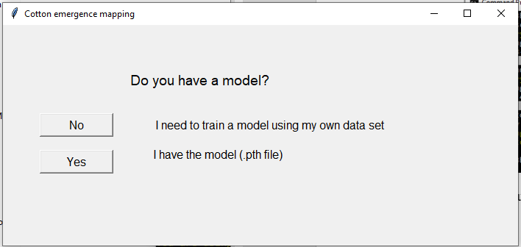

# 4. train your own model

There is a model trained on the related paper used the cotton imagery data set that were collected using a Phantom 4 UAV flying at 10 m AGL at 15 days after planting. The cotton field for the related paper had a planting population of 12 seed m-1and row spacing of 0.97 m. Users may directly use this provided model to map the cotton fields with similar conditions of data collection. However, it is expected that users train a specific model following the processing steps described in this paper using their own data set.

Click the ‘No, I need to train a model using my own data set’ in the main window of the framework to go the training step.

At the beginning of the training step, users may only have the raw UAV RGB image frames. Click the ‘No, I want to label my data set now’.

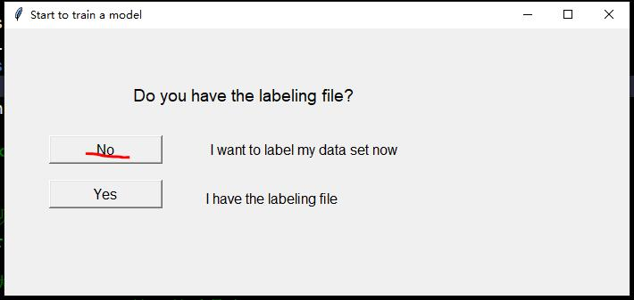

There are two steps needed to do in the training process: seedlings segmentation and crop images. First, click ‘Seedlings segmentation, segment the seedling clusters’.

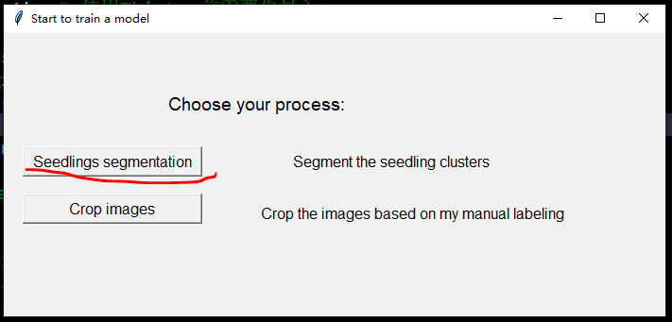

Provided the address of the raw RGB image folder and of the output image folder. Note, when the address is a folder address, it ends with a ‘\’. There are some example images related to the paper in the row_4 folder (please put your raw images in the P4 folder but don’t include P4 in your Img_folder address, just like the example below). Then click ‘Segment!’.

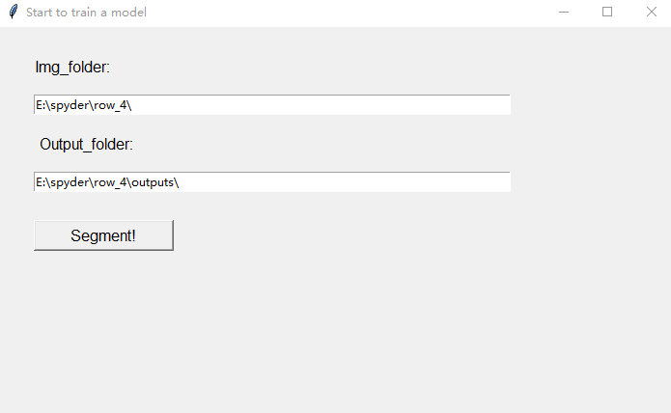

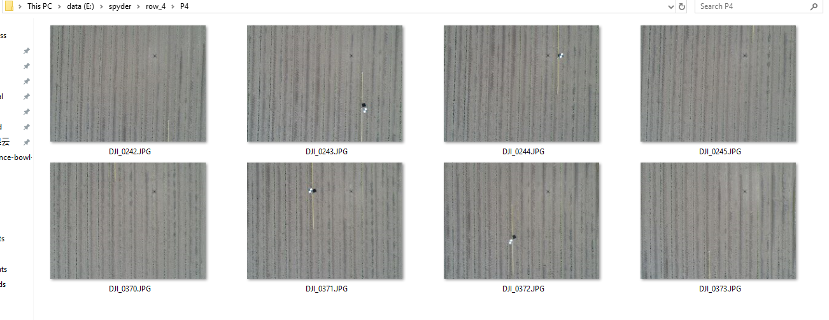

Once the ‘Segment!’ bottom was clicked, the framework will rotate the images with 0-degree angle of cotton rows to vertical axis of the images and save them in the output folder. Then, the users need to follow the guide to use the mouse to draw a rectangle of the regions that have ground labels. Note: since the ground true flags were put in the between rows, you need to select two rows like to example below.

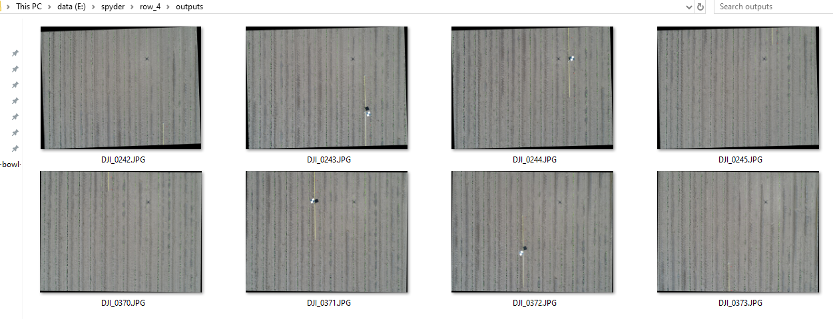



Once the users finish the drawing of all images, the framework will segment each seedling clusters and marked them with blue boxes. Each box has its own id. Then, those segmentation results will be saved as images.

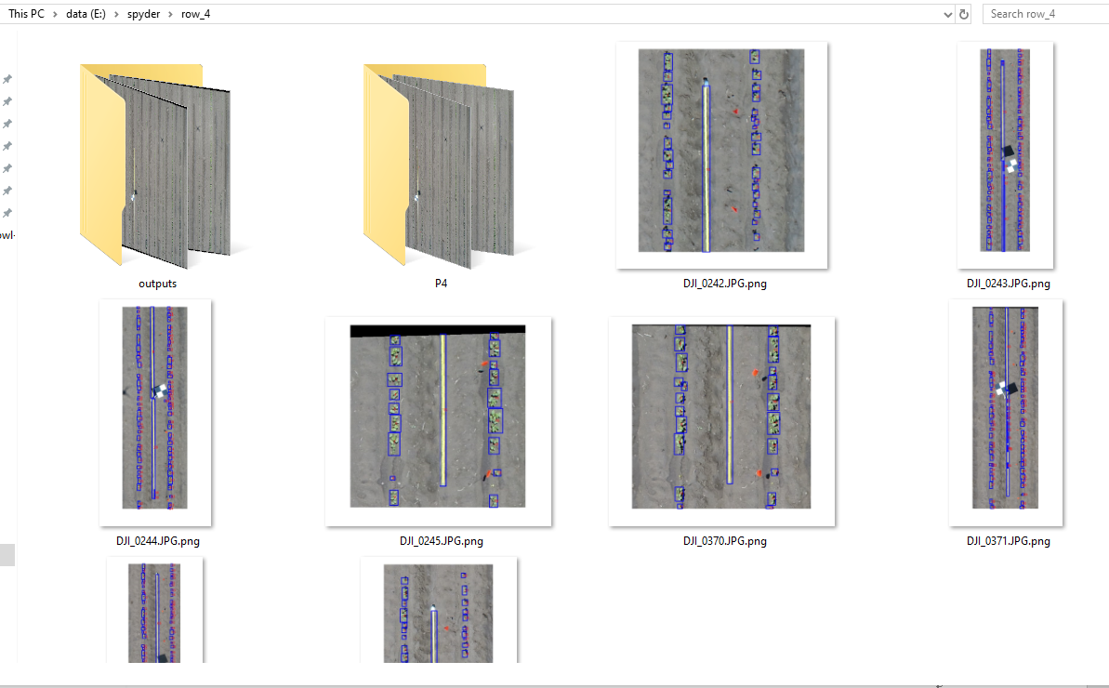

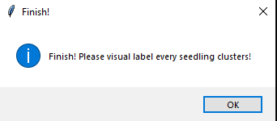

When the process is finished, two files will be generated: 1) excel_data.csv, which recorded the id, location and pixel area of each clusters. The users needed to visual count the seedling numbers based on the segmentation results and type them in the ‘label’ column; 2) row_space.csv, which recorded the row space and the image coordinates of four corners of the rectangles the users drawn.

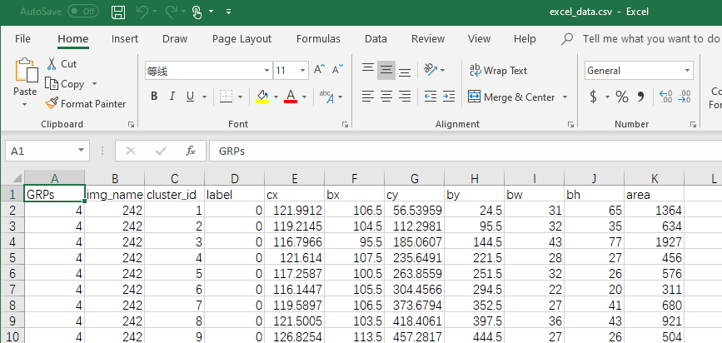

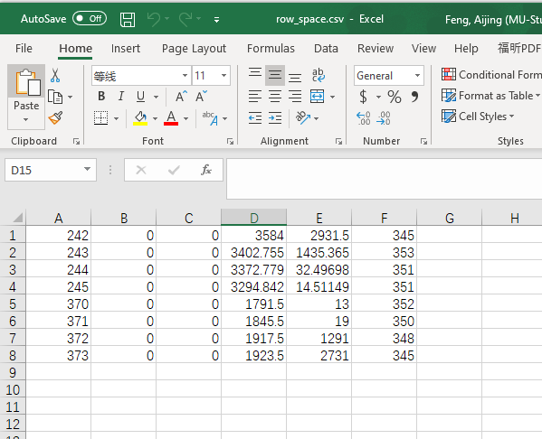

Once the users finished the labeling, they can start to crop the images and build the training data set. We provided an example labelled file. Click ‘Crop images, crop the images based on my manual labelling’.

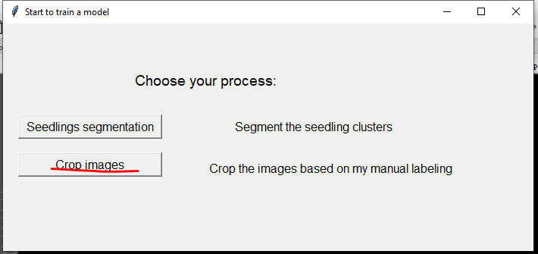

Provided the address of the rotated image folder, the labelling file and the row spacing file. Then click ‘Start to crop!’. Note, when the address is a folder address, it ends with a ‘\’.

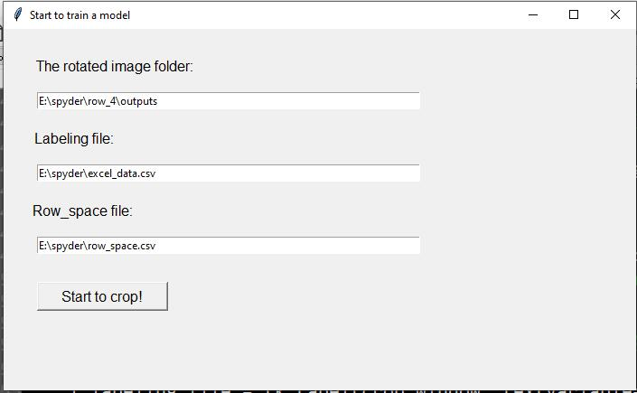

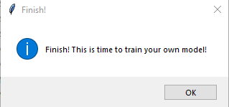

When the cropping is finished, a folder name ‘meter’ is generated. There are images that cropped from 0.7 meter to 1.3 meter from the raw RGB image frames. A file name ‘LablesForMeter.csv’ is also generated, which included the names, related seedling numbers and canopy size of the images in the ‘meter’ folder.

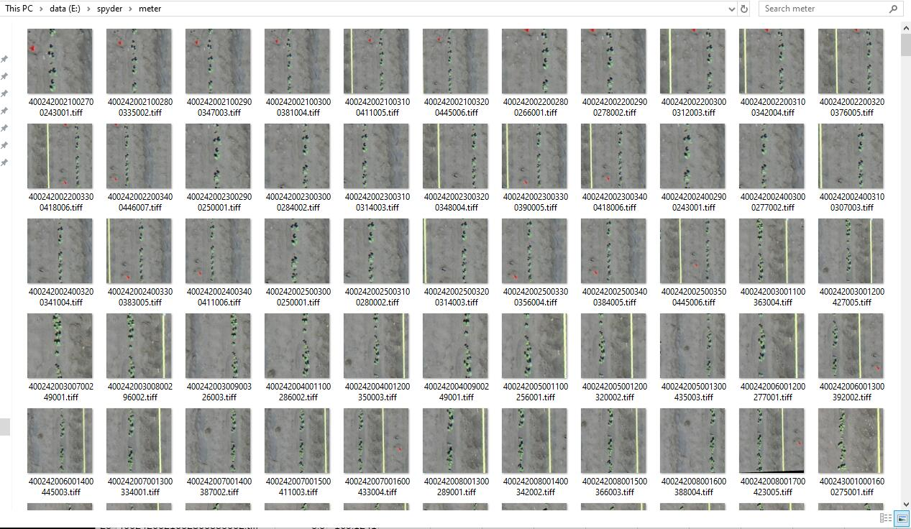

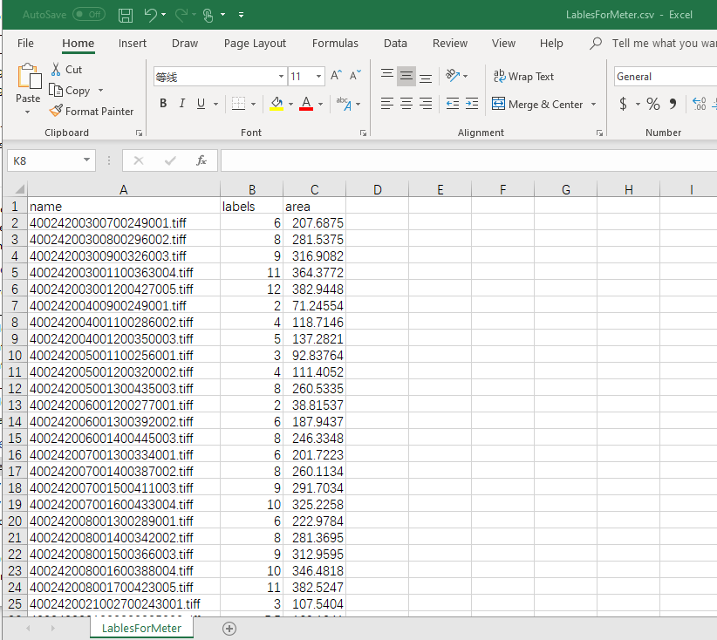

Now, it is time to train your model!

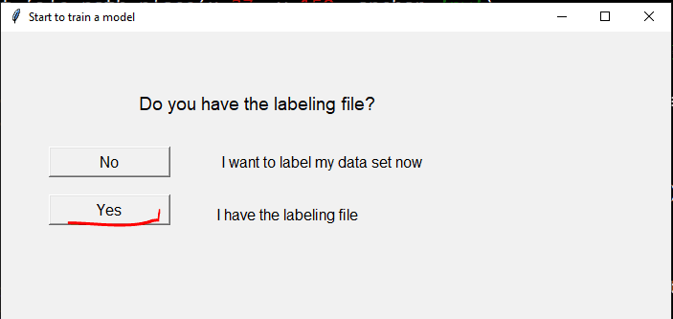

Provided the address of the meter image folder and the labelling. Then click ‘Train!’. *Update 5/22/2020*: some latest pytorch version did not support python v3.6 anymore and the python version needed to be updated to v3.7. Try the update your Matlab version to support python v3.7. If you don’t have license for Matlab R2020a or later, check here for the multiple version specifying: <https://stackoverflow.com/questions/50348975/how-to-change-python-version-in-command-prompt-if-i-have-2-python-version-instal/50349883>. Basically, define Namexxx.bat files to specify which python version you are trying to use. Use ‘[Namexxx gui.py]’ in the cmd to restart this framework. Use ‘[Namexxx -m pip install packageName]’ to install package in a specific python version.

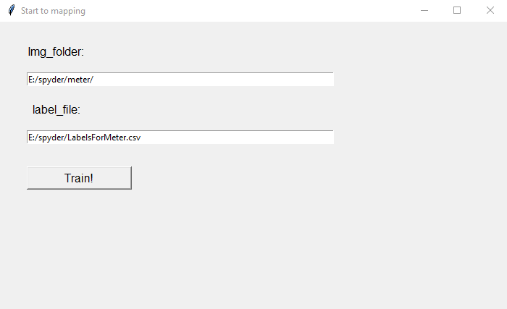

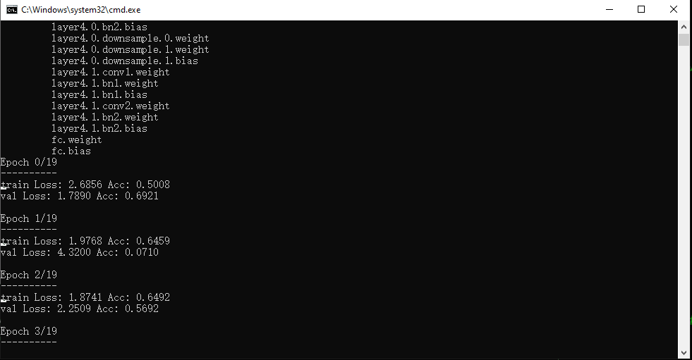

Once the training is finished, a file name 'resnet18.pth' will be generated. This is the model file that included all the trained parameters.

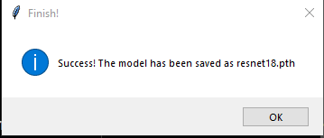

# 5. Seedling emergence mapping

Click the ‘Yes, I have the model (.pth file)’.

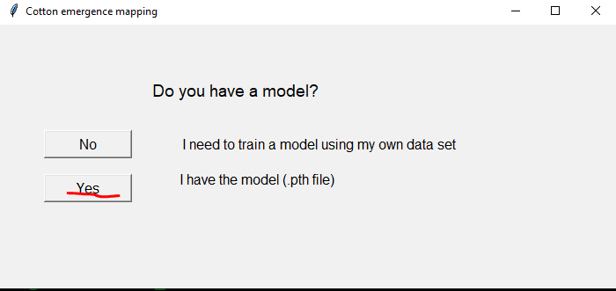

Click the ‘GPS assignment, located the seedlings from individual image frame’.

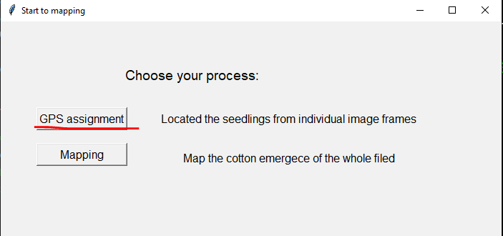

Provided the address of the image folder of the whole field and the output image folder. There are some example images related to the paper in the ‘test_data’ folder. Then click ‘Assign!’.

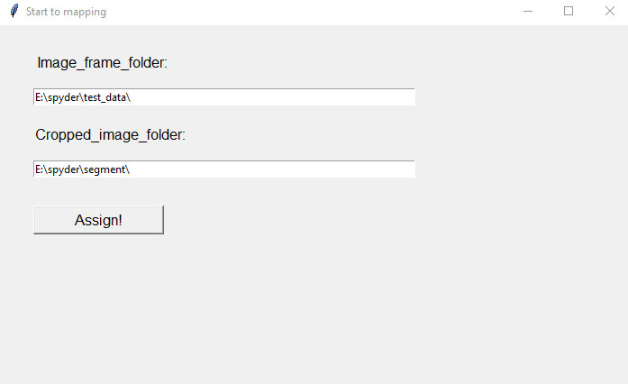

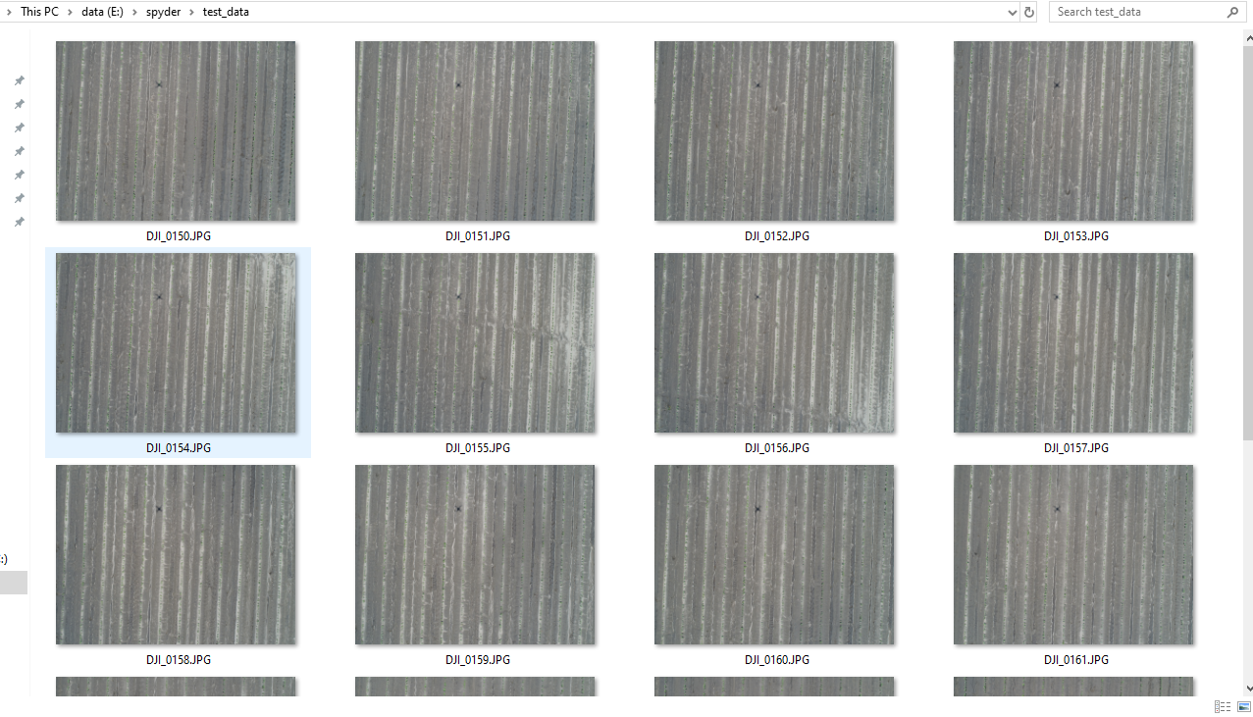

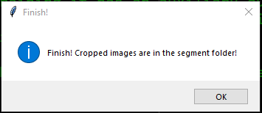

Once it finishes, a folder named ‘segment’ will be generated, and it includes the images segmented from the test images. A file named ‘gps.csv’ will also be generated, which includes the name and related GPS of the segmented images.

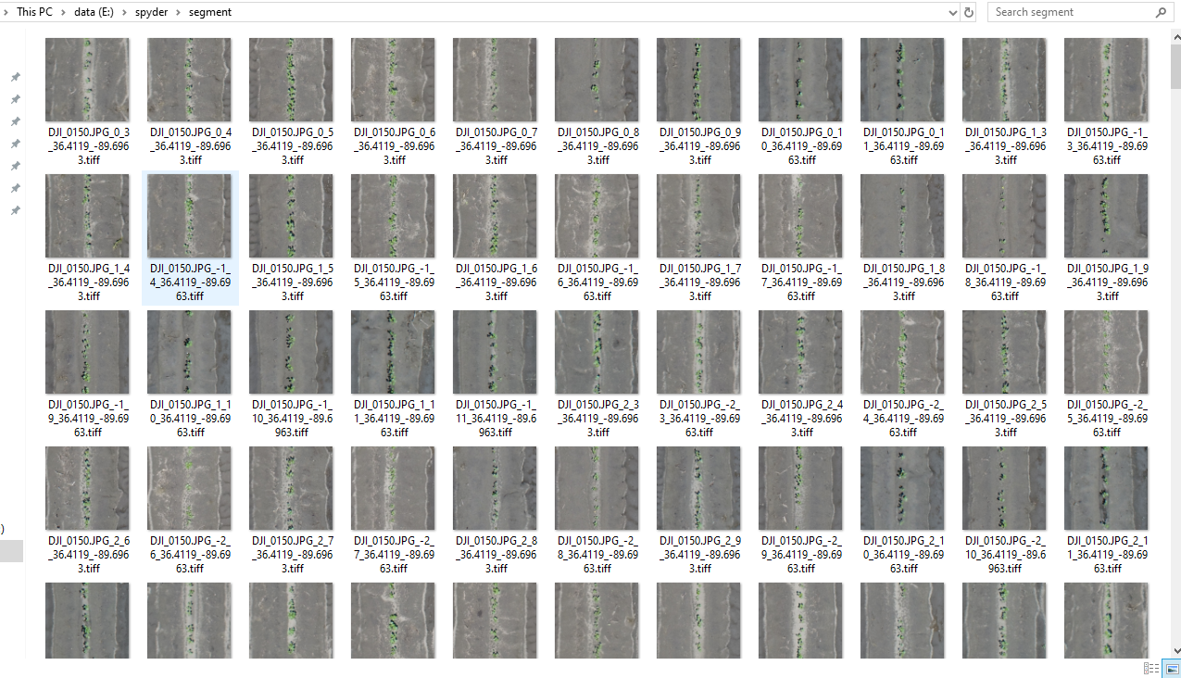

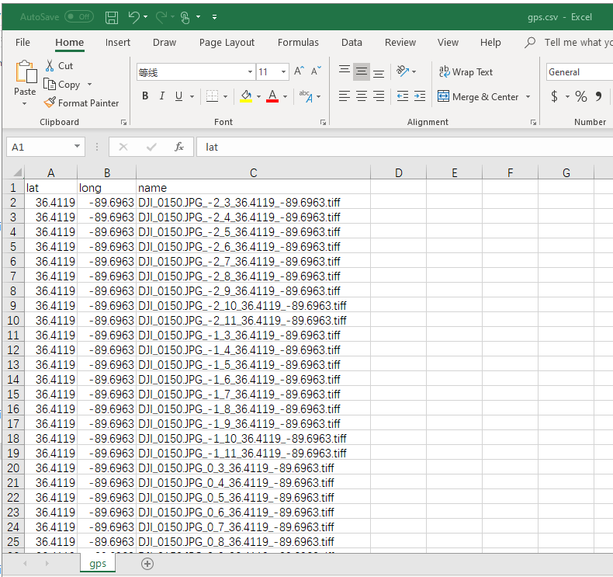

Once it finishes, it is time to map the stand count and the canopy size for the whole field. Click ‘Mapping, map the cotton emergence of the whole field’.

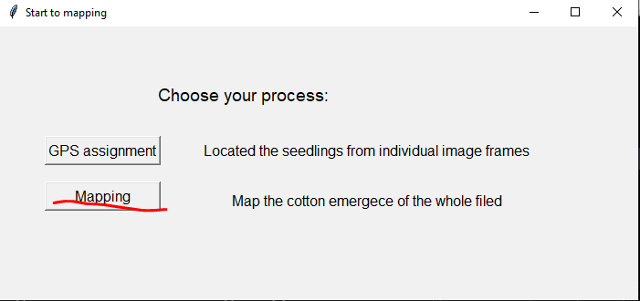

Provided the address of the segmented image folder of the whole field the GPS file and the model file. Then click ‘Start to map!’.

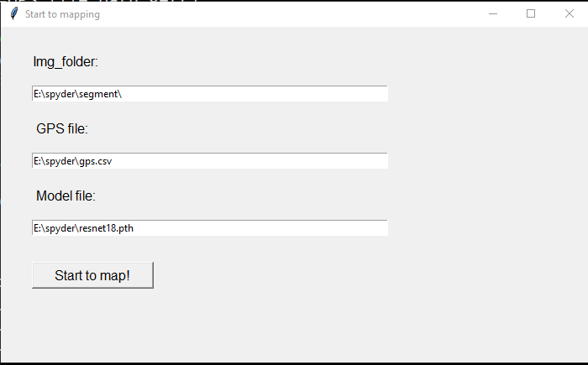

Once it finished, a file named ‘seedling.csv’ will be generated, which includes the prediction of stand count and canopy size with their related GPS.

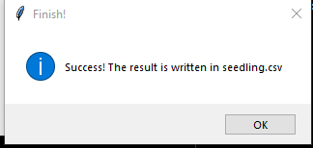

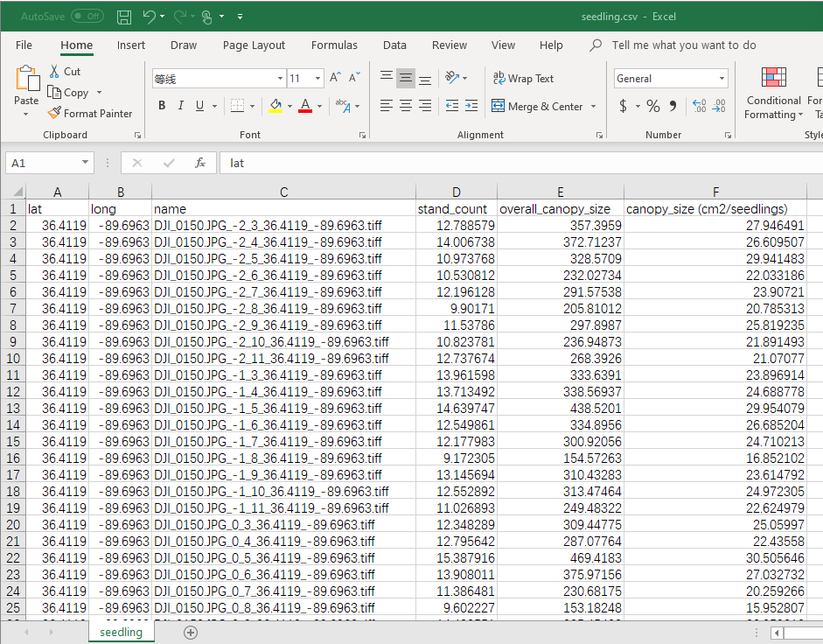

This file can import into Qgis software ([www.qgis.osgeo.org](http://www.qgis.osgeo.org)) to have a visualization map.

